Universal Gravitation W.S.
- Paint spray travels radially away from the nozzle of the can in straight lines. Like gravity, the strength (intensity) of the spray obeys an inverse-square law.
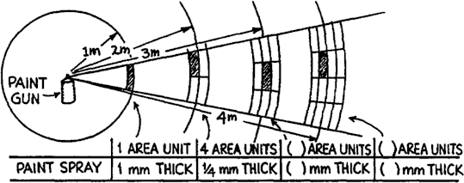

distance | area | thickness
- meters:

- meters:
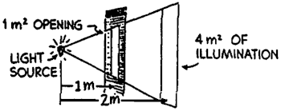
Refer to the following information for the next two questions.

A small light source located 1 meter in front of an opening of area 1 m² illuminates a wall behind. If the wall is 1 meter behind the opening (2 meters from the light source), the illuminated area covers 4 m².
- How many square meters will be illuminated if the wall is

- m from the source? or
10 m from the source?

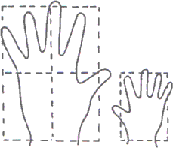

Now, hold your bands outstretched, one twice as far from your eyes as the other, and make a casual judgment as to which hand looks bigger. Most people see them to be about the same size, while many see the nearer hand as slightly bigger. Almost nobody upon casual inspection sees the nearer hand as four times as big. But because your vision depends upon an inverse-square law, the nearer hand should appear twice as tall and twice as wide, and therefore occupy four times as much of your visual field, as the farther hand. Your belief that your hands are the same size is so strong that you likely overrule this information. Now if you overlap your hands slightly and view them with one eye closed, you’ll see the nearer hand as clearly bigger. This raises an interesting question:
- What other illusions do you have that are not so easily checked?

Some of the physics laws that obey an inverse square relationship are intensity of light and sound as well as electric and gravitational field strength.
The equation for the law of universal gravitation is
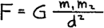

where F is the attractive force between masses m1 and m2 separated by distance d. G is the universal gravitational constant and relates F to the masses and distance as the constant π similarly relates the circumference of a circle to its diameter.

By substituting changes in any of the variables into this equation, we can predict how the others change. For example, we can see how the force changes if we know how either or both of the masses change, or how the distance between their centers changes.

Suppose, for example, that one of the masses somehow is doubled. Then substituting 2m1 for m1 in the equation gives
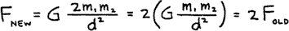

So we see the force doubles also. Or suppose instead that the distance of separation is doubled. Then substituting 2d for d in the equation gives

And we see the force is only ¼ as much.
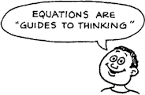

Use this method to solve the following problems. Write the equation and make the appropriate substitutions.

- If both masses are doubled, what happens to the force?

- If the masses are not changed, but the distance of separation is reduced to ½ the original distance, what happens to the force?

- If the masses are not changed, but the distance of separation is reduced to ¼ the original distance, what happens to the force?

- If both masses are doubled, and the distance of separation is doubled, show what happens to the force.

- If one of the masses is doubled, the other remains unchanged, and the distance of separation is tripled, show what happens to the force.

- Consider a pair of binary stars that pull on each other with a certain force. Would the force be larger or smaller if the mass of each star were three times as great when their distance apart is three times as far? Describe how the new force will be compared to the first one.

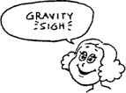
- If the moon is “falling” toward the Earth, why doesn’t it reach it?

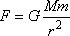
- If the force due to gravity on you due to the earth is , what is the force due to gravity on the Earth due to you? Explain.

- According to Newton’s law of gravitation, how is the force of gravity affected when the distance between two masses is doubled?

- Being an ultra-conscientious consumer, would you rather buy items by mass or by weight at the Dead Sea Supermarket or at the Top-of-Mt. Everest Supermarket? Explain.

- Suppose a hole is drilled through the center of the earth to the other side. If you dropped a stone down the hole, what would happen?

- If you drive down a street past a large massive skyscraper, does the force of gravity due to the skyscraper accelerate your car on approach and decelerate it after you go past? Explain.

- The Sun is much more massive than the Earth (about a million times more). Why doesn’t the gravitational attraction of the Sun pull us off the Earth?

- The law of gravitation is an inverse-square law. Suppose it varied as .

  - 1/r.
(b) 1/r³.
- The high tide on the side of the Earth nearest the moon occurs sometime later than when the moon is highest in the sky. What causes this time lag?

- Would you expect to weigh more at full moon or at new moon? Why is this effect not detected?

- It was once speculated that the Earth had a sister planet at the same distance from but on the opposite side of the Sun, so it could never be seen. How could it be proved that there is no such planet, both directly and indirectly?

- Why is the acceleration due to gravity on the moon one-sixth of that on Earth?

- An astronaut on a “moon walk” easily picks up a lot of equipment that would be too heavy for him on earth (backpacks of 300 lbs). Explain how this is possible.

- Is the acceleration due to gravity different on the surfaces of different planets? Explain.

- The planet Saturn is 94 times more massive than Earth, but the acceleration due to gravity on the surface of Saturn is about the same as g on Earth. What does that tell you in general about the size of Saturn? Can you give an estimate of the radius of Saturn compared to Earth’s?

- Is it correct to speak about the weight of a planet? Explain.
- Sketch the gravitational field around two equal masses separated by a short distance.

- A black hole is no more massive than the original star. Why is the gravity of a black hole so great near the “hole” (within original star radius)?

- How far from the Earth would you have to go to be truly weightless?

- Considering only the Earth and the moon, is it possible for an astronaut on a moon trip to have zero gravity? Explain.

- Why does the moon have no atmosphere, while the Earth does?

- What is the gravitational force of attraction between two 5-kg masses held 1 meter apart?

- How would the attractive force in Question (31) change if the two masses were moved to new positions so that they are only separated by half a meter?

- How would the attractive force in Question (31) change if the two masses were moved to new positions located 10-meters apart?

- What does a 500-kg mass weigh on the surface of the earth?

- What does a 500-kg mass weigh in space if it is placed 60 earth radii above the surface of the earth?

- What would a 500-kg mass weigh on Mars if Mars has a mass approximately equal to 1/10th the mass of the earth and has a radius equal to roughly ½ of the radius of the earth?

- What is the acceleration due to gravity on the surface of Mars?

Some formulas you might like to reference as you continue to complete this worksheet:

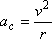

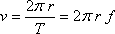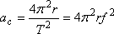

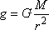

Refer to the following information for the next four questions.

38. On average, the distance from the earth to the sun (from center to center) is 150 x 109 meters and it takes the earth 365 days to make one complete revolution.

(a) What is the earth's average tangential velocity as it circles the sun?

- What is the strength of the sun's gravitational field at the earth's orbital radius?

- What is the mass of the sun?

(d). What is the magnitude of the gravitational force of attraction between the earth and the sun?
That is, how much does the earth "weigh" in the sun's gravitational field?

39. An imaginary planet has a mass twice as great as the earth’s but the same radius.

At what height above the surface of the planet would the planet's acceleration due to gravity equal that on the earth's surface?

Refer to the following information for the next three questions.

40. The earth-to-moon distance (from center to center) is 3.84 x 105 km.

- What is the strength of the earth's gravitational field at the moon's location?

- What is the moon's tangential velocity about the earth?

- What is the period of the moon in seconds?

- Do you weigh more in a deep-mine in Africa or on the Earth’s crust-surface in Africa? Explain.

- Do you weigh more at sea-level in Equador or at sea-level in Alaska? Explain.

- REVIEW: A student standing on the edge of a swimming pool sees a painted mark on the bottom of the pool. The mark appears to be at a shallower depth than the actual depth of the pool. Which of the following descriptions of light waves best explains this observation?

A. Light from the mark travels through the water in a curved path.
B. Light from the mark is refracted as it travels from the water to the air.
C. Light from the mark is reflected as it travels from the water to the air.
D. Light from the mark bounces off the boundary between the water and the air.

